NOCO TRIPLE THREAT GIRLS BASKETBALL
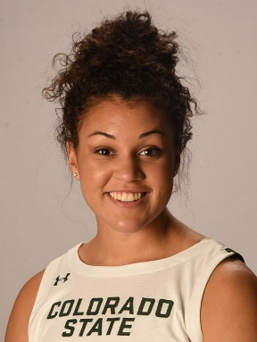
(Northern Colorado’s ONLY Nationally recognized club opportunity)

BLUESTAR 2026 TRYOUTS
Coaches: CSU’s Myanne Hamm &
Joe Mivshek

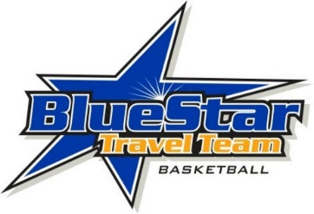
*Players going into 7th Grade invited to tryout*
2020 – 2021
Date: Aug. 6th & Aug. 10th
Location / Time: Power to Play 6:30-8pm
To Register or for Tryout Information Contact:
Todd Matkin 970-658-7644 or email: tmatkin9@gmail.com

We have established ourselves as one of the best girls’ teams/programs in the state! Our 2023 Elite team has paved the way for the top players & families(Colorado, Wyoming and Western Nebraska). We are an affiliate with the Boulder Rockies as the only teams recognized by Blue Star Nike as the Colorado representatives.

Benefits – Not only the most affordable opportunity in the area/state but also include discounted registrations for teams and individuals to any Blue Star/USJN Event, discounts and priority registration to any individual Showcase Evaluation camps and also discounted apparel with our agreement with Eastbay and Nike for team apparel, clothing, etc

Our coaches and teams focus on high level player development & character development of the player both on and off the court, while also offering player exposure against high level competition at both the State, Regional, and National levels.
(**Deadline to register for this Tryout/Opportunity is Aug. 2nd 2020**) **We Do Not Charge For Tryouts!!**
Player Name:_______________________ DOB:__________ Position:____________Grade (2020-2021):________
School:___________________Height:___________________ Phone #s:_________________________________
Parent(s) Names:_________________________________Email:_____________________________
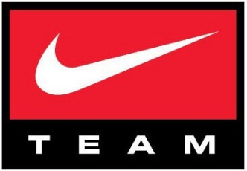
Address:___________________________________________________________
Uniform # Top 3 Choices:_______, ________, ________

Cost Breakdown:
Fees:
-$400 Gear (Includes Custom Nike Light and Dark Uniforms ($115 x 2), Nike Long Sleeve Shooting Shirt ($40), Practice Jersey ($30) , and Nike Elite Backpack ($50), **Nike Team Travel Bag (Optional $50)**.
-**This will be for all new players and we will plan on at least 2 years of use so not
Gym Fee(’20-‘21 Year): PTP Courts are $50/hour Year of Ct. Rentals will be $608/player for year.
Blue Star Affiliation Fee (’20-’21): $60
Team Insurance:$11 per player
NCAA Coach Certification: $13 per player

Fall Power to Play League:
-$156 per player according to PTP’s Website

Winter Power to Play League:
-$156 per player according to PTP’s Website

Spring Tourney’s: ($210/player) Dates “Tentative” based on 2020
(4/6) iHoop Nation Spring Classic ($250)
(4/26-4/28) Arizona Elite Showcase or Heart of Dallas Showcase ($795)
(5/4-5/5) Triple Crown Colorado Finest or similar TBA ($450)
(5/15-5/17) Power to Play Showcase Event ($400)

June PTP League: ($89/player)

July Tourney’s 3 Showcase Events “Tentative Tournaments Based on Summer 2020”: ($155/Player)
-USJN Indianapolis ($600/team) 7/5-7/8
-PTP Mid July event ($400/team) 7/19-7/21
-Denver Mtn. USJN Blue Star Mountain Madness ($400) 7/24-7/26

TOTAL: ($1848/player for entire year)
**Payments can be broken down into 3 Payments**($616 8/31, $616 10/1, $616 1/31)

(**Once players have their Nike Blue Star Gear purchased their first year the following years costs will be Regular fees/event expenses minus Equipment costs)
Only Expenses not covered is Travel Expense (All players/families are responsible for paying their part of travel event fees and travel expenses) **Players that quit, leave the team, or are removed from the team will NOT receive a refund on payments made**
**Travel Expenses Not included but will be split evenly to cover expenses by all players even if not going and no replacement player is found(Air, Hotel, Transportation, Team Dinners 1-2x)
(FORMER PLAYERS)
