NOCO TRIPLE THREAT GIRLS BASKETBALL
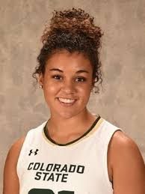
(Northern Colorado’s ONLY Nationally recognized club opportunity)
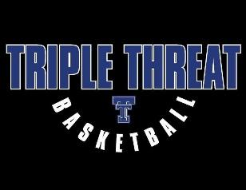
BLUESTAR CLUB TRYOUTS

(Current 7th Grade and 6th Grade)
Head Coach: Myanne Hamm
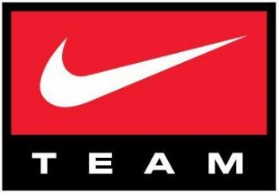
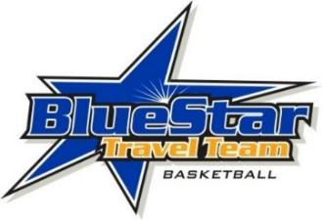
Former Colorado State Rams WBB
Date: Sunday Mar. 7th
ONLY $727 (Covers March-July)
**Must Register by March 5th**
Location / Time: Power to Play 6:30-8:30pm
To Register or for Tryout Information Contact:
Todd Matkin (Director and 2023 Elite BlueStar Coach)
tmatkin9@gmail.com or 970-658-7644
Triple Threat has established themselves as one of the best & most affordable girls’ teams/programs in the state! Our 2023 Elite team has paved the way for the top players & families (Colorado, Wyoming and Western Nebraska). We are an affiliate with the Boulder Rockies as the only teams recognized by Blue Star Nike as the Colorado representatives.

Benefits – Not only the most affordable opportunity in the area/state but also include discounted registrations for teams and individuals to any Blue Star/USJN Event, discounts and priority registration to any individual Showcase Evaluation camps and also discounted apparel with our agreement with Eastbay and Nike for team apparel, clothing, etc

Our coaches and teams focus on high level player development & character development of the player both on and off the court, while also offering player exposure against high level competition at both the State, Regional, and National levels.
(**Deadline to register for this Tryout/Opportunity is March 5th **) **We Do Not Charge For Tryouts!!**
Player Name:______________________ DOB:___________ Position:__________ Grade:_____________
School:_____________________ Height:______________ Phone #s:_____________________________________
Parent(s) Names:______________________ ___Email:__________________ ______________________
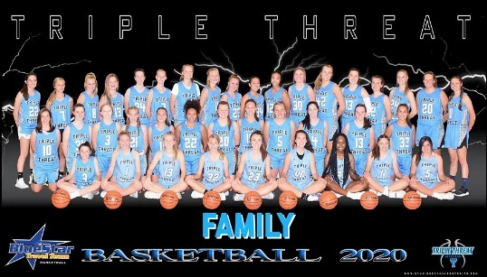
Address:_______________________ ____________________________________
Uniform # Top 3 Choices:________,_________,_________

Cost Breakdown:
Gear /Gym Fees/Insurance Total: ($381)
-$250 Gear (Includes Custom Nike Light and Dark Uniforms ($90 x 2), Nike Long Sleeve Shooting Shirt ($40), Practice Jersey ($30)
-**This will be for all new players or players that do not have the above mentioned items.
Gym Fee(’20-‘21 Year): $120 per player
Team Insurance:$11 per player
Coach Stipend (Gas, Meals, Time) $50/player (Paid directly to the coach upon first practice)

Spring Events (4): ($152/player)
-(4/10-4/11) iHoop Nation Super 48 ($395)
-(4/24-4/25) Power to Play Coaches Classic ($325)
-(5/1) Power to Play Spring Blockbuster ($305)
-(5/15-5/16) Power to Play National Spring Finals ($345)

June Event: ($89/player)
-Power to Play League Season ($800/team Tuesday Nights)

Summer Events ($105/player)
-(7/3-7/4) iHoop Nation Summer Heat Jam ($295)
-(7/17-7/18) Power to Play Colorado Mtn. Jam ($325)
-(7/31) Power to Play End of Summer Challenge ($325)

TOTAL DUE: $727 (per player) ***Covers March through July***

**Players that quit, leave the team, or are removed from the team will NOT receive a refund on payments made**

(FORMER PLAYERS)
